**ASSIGNMENT – 3**

**ON: DATA CONTROL – DCL**

**Q6. Write an INSERT statement in a text file named loademp.sql to load rows into the MY_EMPLOYEE table. Concatenate the first letter of the first name and the first seven characters of the last name to produce the user ID.**

Ans6.

INSERT INTO MY_EMPLOYEE

(ID, LAST_NAME, FIRST_NAME, USERID, SALARY)

VALUES (&ID, '&LAST_NAME', '&FIRST_NAME',

LOWER(SUBSTR('&FIRST_NAME',1,1) || SUBSTR('&LAST_NAME',1,7)),

&SALARY);

**Verification table 1 -**

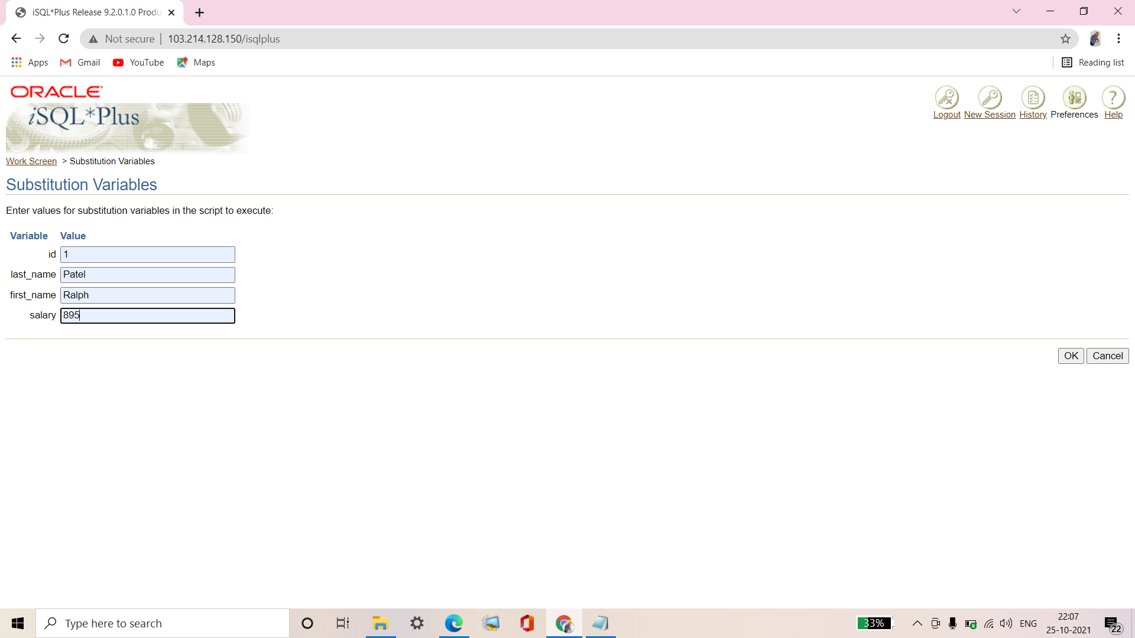

**Verification table 2 -**

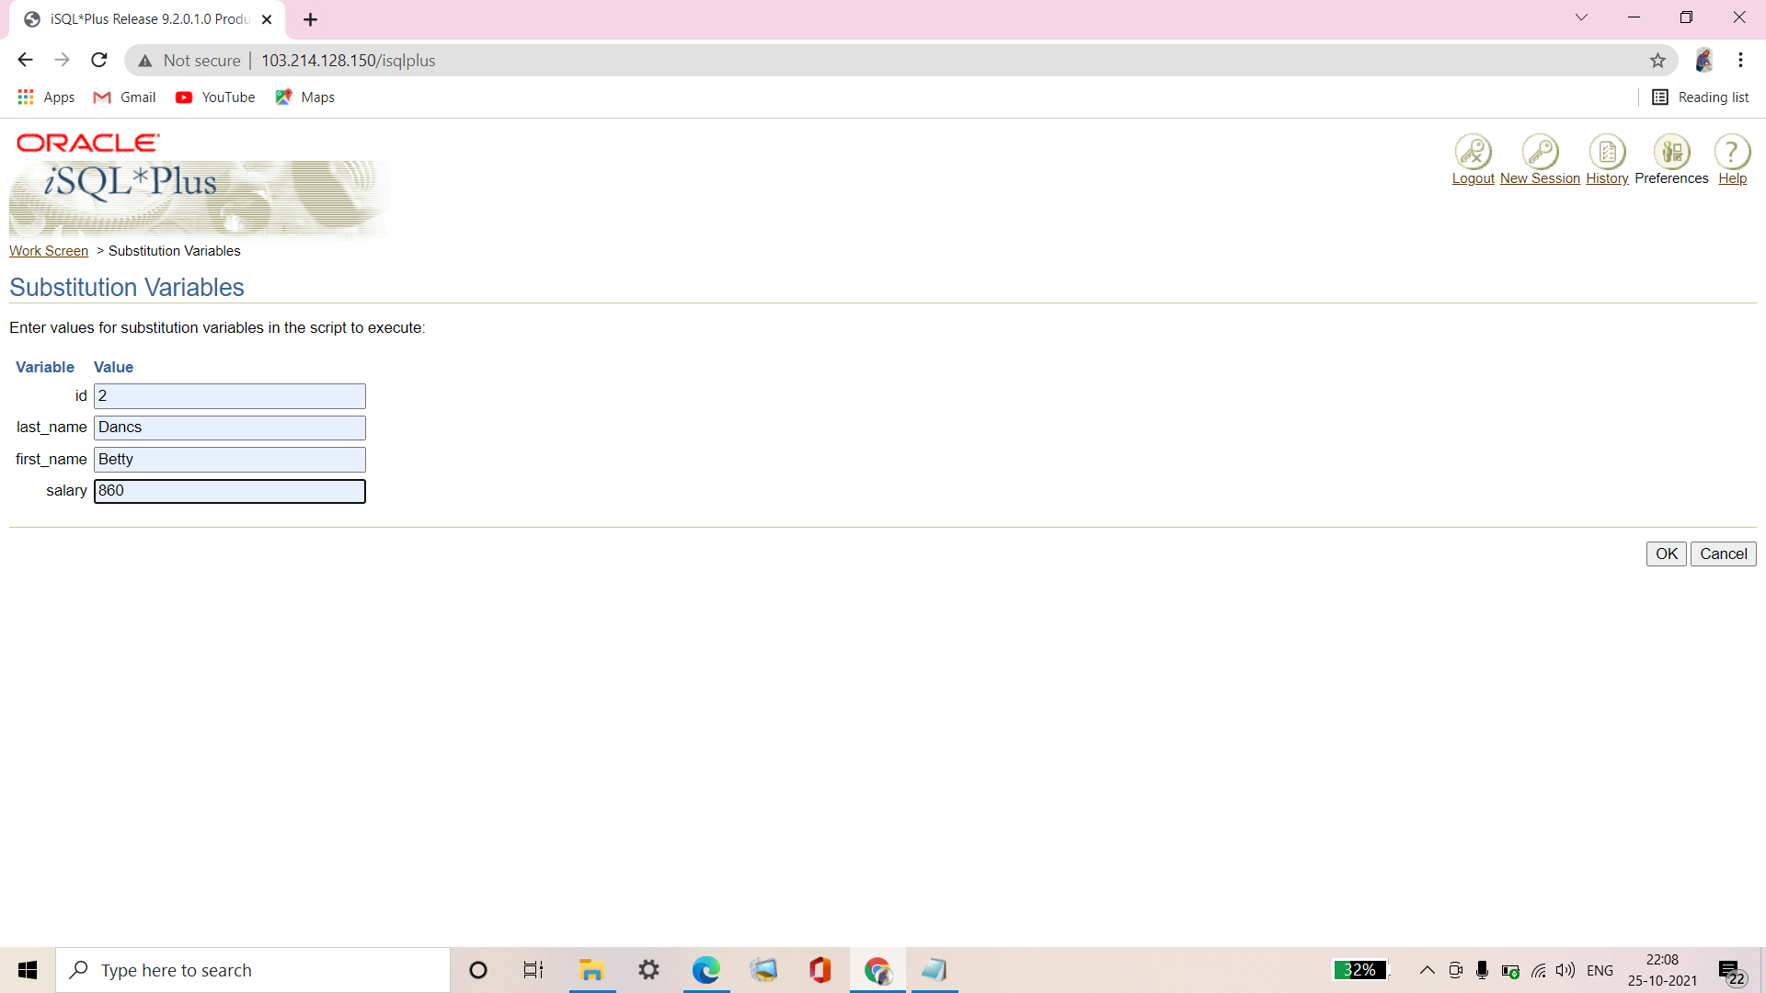

**Q7. Populate the table with the next two rows of sample data by running the INSERT statement in the script that you created.**

Ans7.

INSERT INTO MY_EMPLOYEE

(ID, LAST_NAME, FIRST_NAME, USERID, SALARY)

VALUES (&ID, '&LAST_NAME', '&FIRST_NAME',

LOWER(SUBSTR('&FIRST_NAME',1,1) || SUBSTR('&LAST_NAME',1,7)),

&SALARY);

**Verification table 1 -**

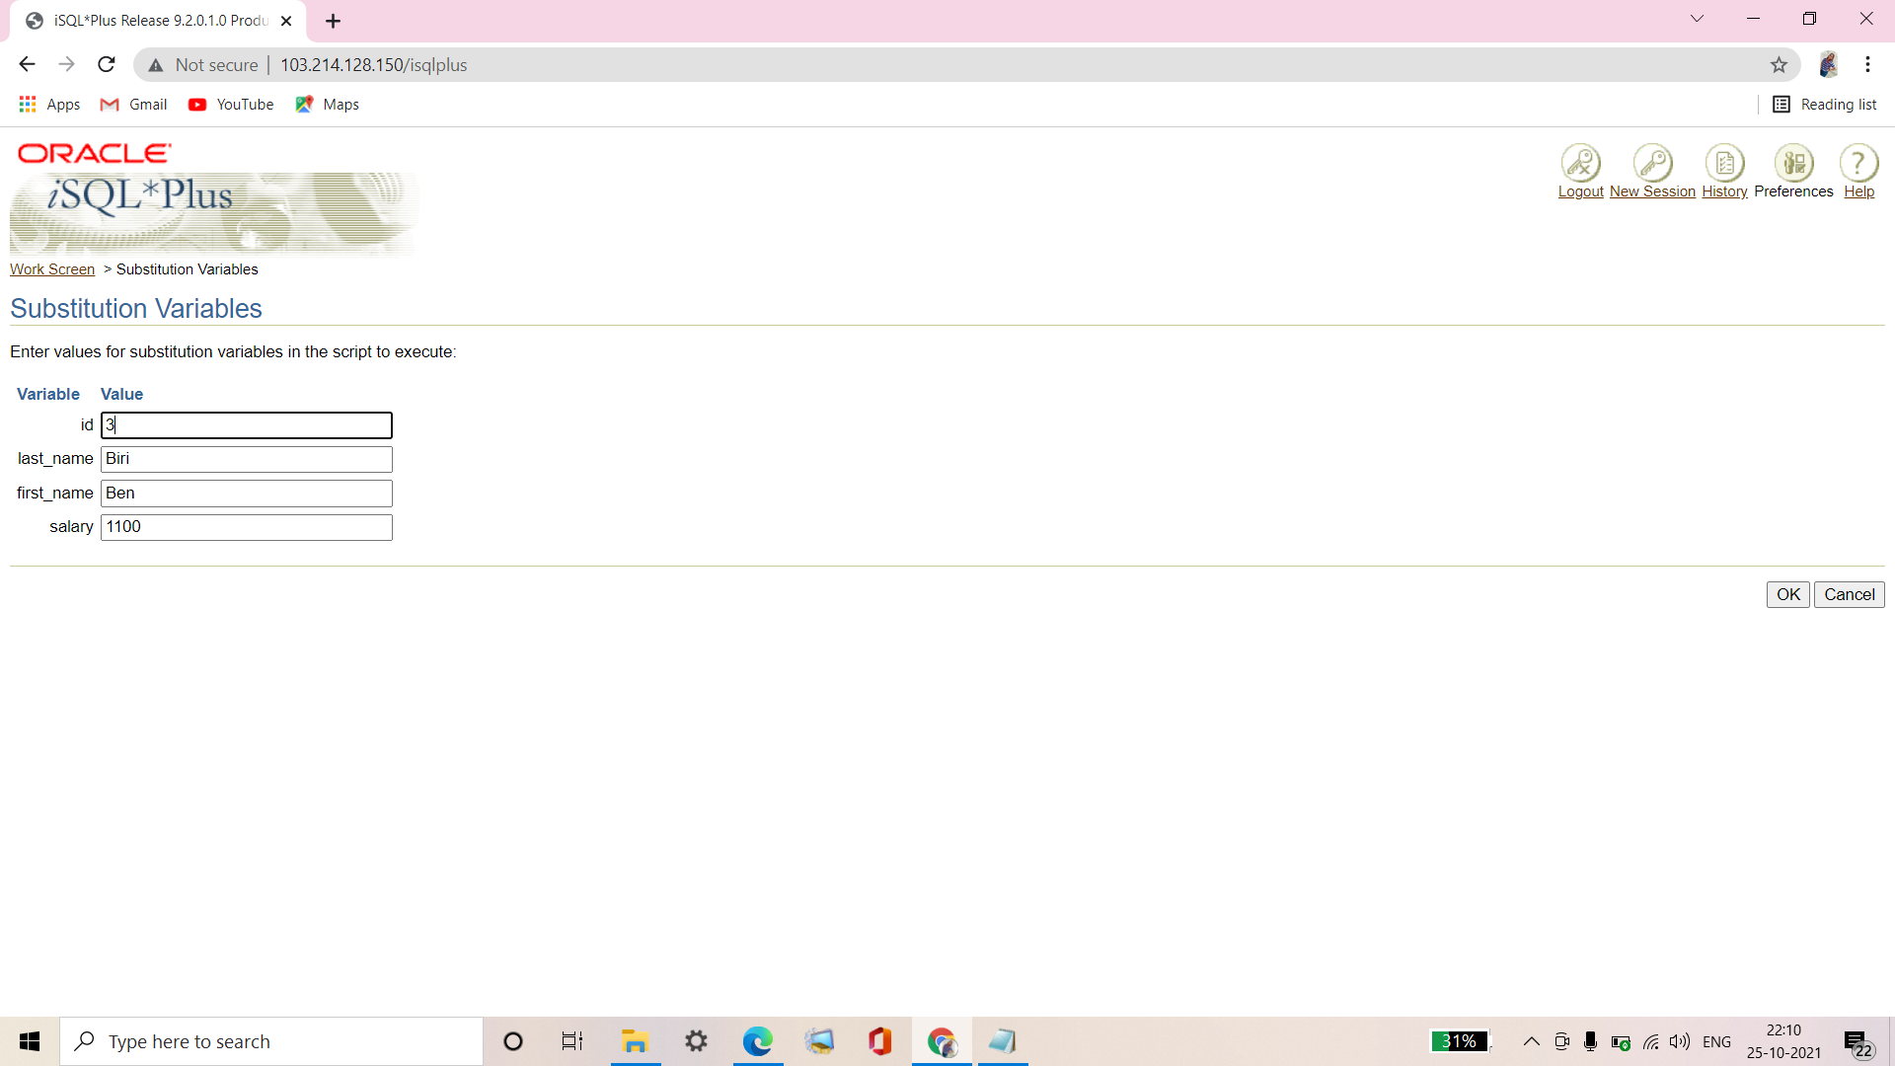

**Verification table 2 -**

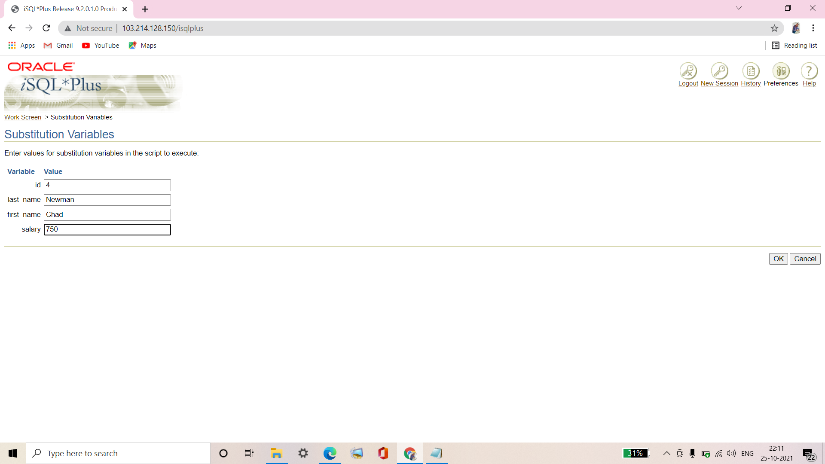

**Q8. Confirm your additions to the table.**

Ans8.

SELECT * FROM MY_EMPLOYEE;

**Verification table -**

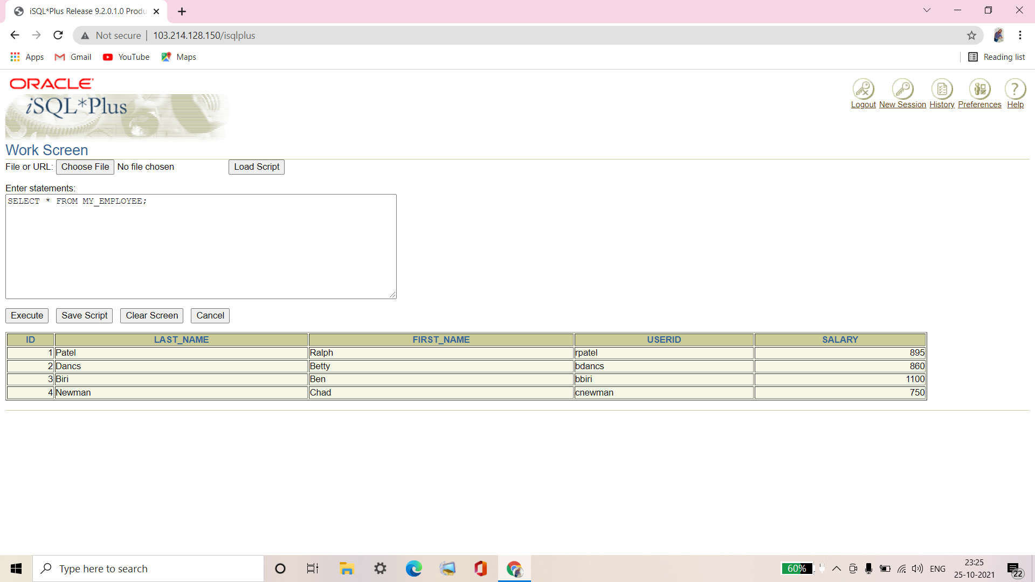

**Q9. Make the data additions permanent.**

Ans9.

COMMIT;

**Update and delete data in the MY_EMPLOYEE table.**

**Q10. Change the last name of employee 3 to Drexler.**

Ans10.

UPDATE MY_EMPLOYEE

SET LAST_NAME='Drexler'

WHERE ID=3;

**Q11. Change the salary to 1000 for all employees with a salary less than 900.**

Ans11.

UPDATE MY_EMPLOYEE

SET SALARY=1000

WHERE SALARY<900;

**Q12. Verify your changes to the table.**

|  |  |  |  |  |
| --- | --- | --- | --- | --- |
| **ID** | **LAST_NAME** | **FIRST_NAME** | **USERID** | **SALARY** |
| **1** | **Patel** | **Ralph** | **rpatel** | **1000** |
| **2** | **Dancs** | **Betty** | **bdancs** | **1000** |
| **3** | **Drexler** | **Ben** | **bbiri** | **1100** |
| **4** | **Newman** | **Chad** | **cnewman** | **1000** |

Ans12.

SELECT * FROM MY_EMPLOYEE;

**Verification table -**

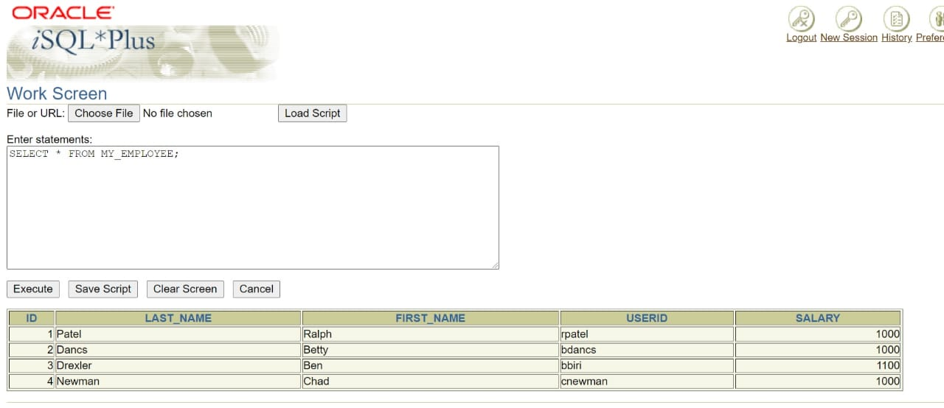

**Q13. Delete Betty Dancs from the MY_EMPLOYEE table.**

Ans13.

DELETE FROM MY_EMPLOYEE

WHERE LAST_NAME='Dancs';

**Q14. Confirm your changes to the table.**

|  |  |  |  |  |
| --- | --- | --- | --- | --- |
| **ID** | **LAST_NAME** | **FIRST_NAME** | **USERID** | **SALARY** |
| **1** | **Patel** | **Ralph** | **rpatel** | **1000** |
| **3** | **Drexler** | **Ben** | **bbiri** | **1100** |
| **4** | **Newman** | **Chad** | **cnewman** | **1000** |

Ans14.

SELECT * FROM MY_EMPLOYEE;

**Verification table -**

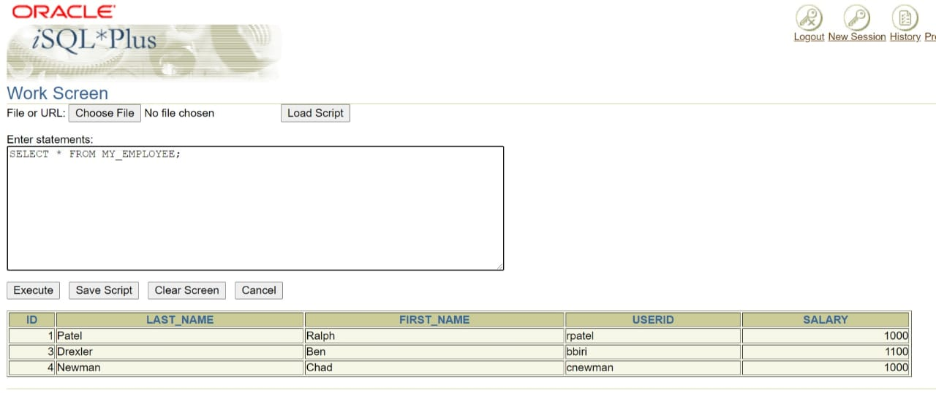

**Q15. Commit all pending changes.**

Ans15**.**

COMMIT**;**

**Control data transaction to the MY_EMPLOYEE table.**

**Q16. Populate the table with the last row of sample data by modifying the statements in the script that you created in step 6. Run the statements in the script.**

Ans16.

INSERT INTO MY_EMPLOYEE

(ID, LAST_NAME, FIRST_NAME, USERID, SALARY)

VALUES (&ID, '&LAST_NAME', '&FIRST_NAME',

LOWER(SUBSTR('&FIRST_NAME',1,1) || SUBSTR('&LAST_NAME',1,7)),

&SALARY);

**Verification table -**

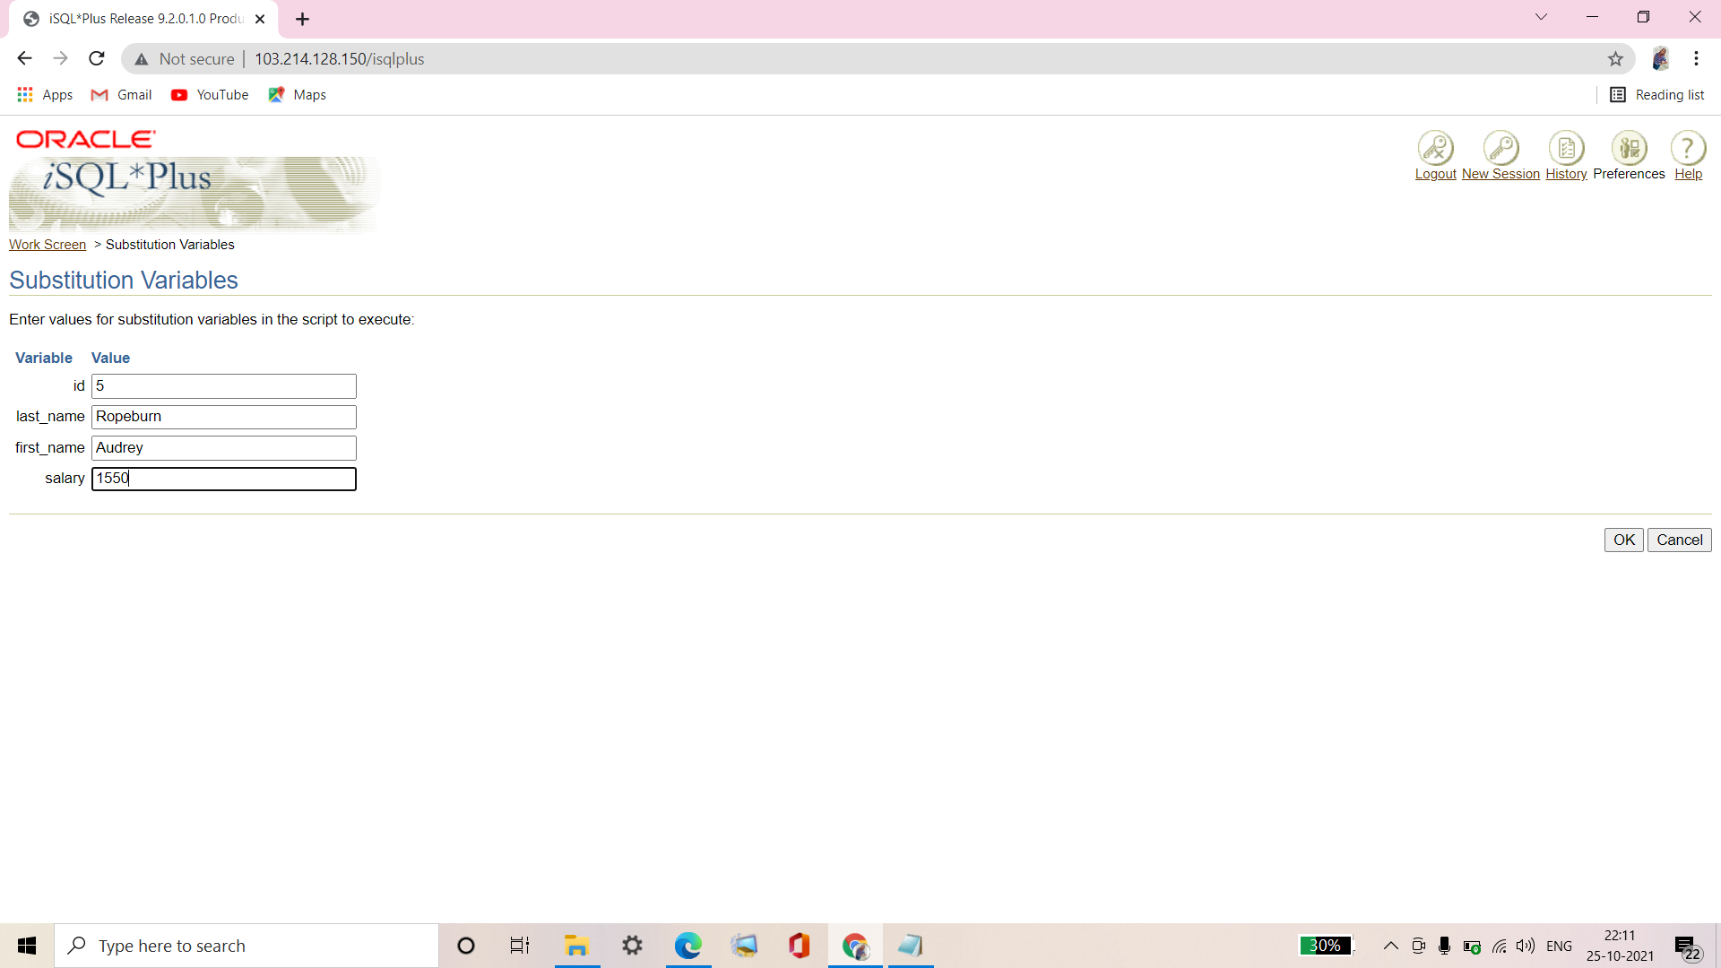

**Q17. Confirm your addition to the table.**

|  |  |  |  |  |
| --- | --- | --- | --- | --- |
| **ID** | **LAST_NAME** | **FIRST_NAME** | **USERID** | **SALARY** |
| **1** | **Patel** | **Ralph** | **rpatel** | **1000** |
| **3** | **Drexler** | **Ben** | **bbiri** | **1100** |
| **4** | **Newman** | **Chad** | **cnewman** | **1000** |
| **5** | **Ropeburn** | **Audrey** | **aropebur** | **1550** |

Ans17**.**

SELECT * FROM MY_EMPLOYEE;

**Verification table -**

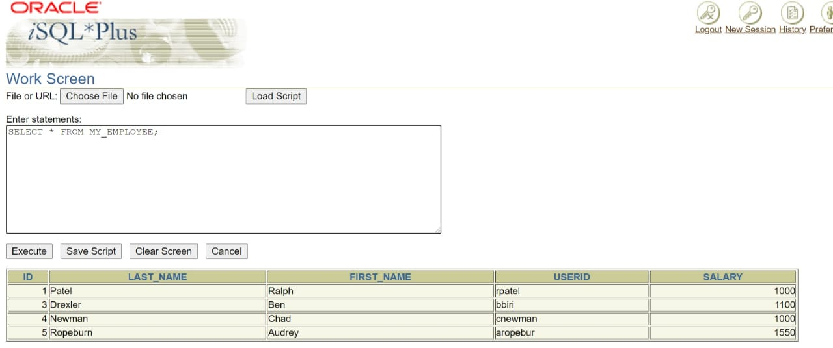

**Q18. Mark an intermediate point in the processing of the transaction.**

Ans18.

SAVEPOINT STEP17;

**Q19. Empty the entire table.**

Ans19.

DELETE FROM MY_EMPLOYEE;

**Q20. Confirm that the table is empty.**

Ans20.

SELECT * FROM MY_EMPLOYEE;

**Verification table -**

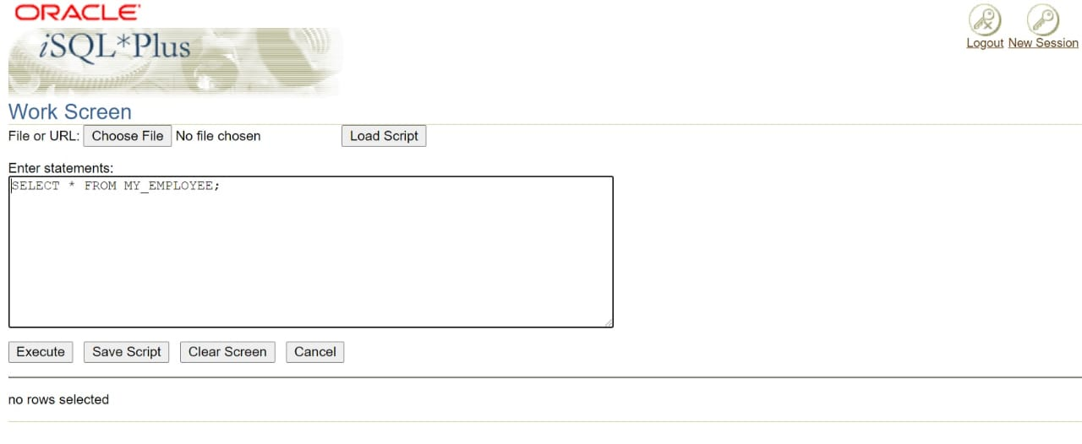

**Q21. Discard the most recent DELETE operation without discarding the earlier INSERT operation.**

Ans21.

ROLLBACK TO STEP17;

**Q22. Confirm that the new row is still intact.**

|  |  |  |  |  |
| --- | --- | --- | --- | --- |
| **ID** | **LAST_NAME** | **FIRST_NAME** | **USERID** | **SALARY** |
| **1** | **Patel** | **Ralph** | **rpatel** | **1000** |
| **3** | **Drexler** | **Ben** | **bbiri** | **1100** |
| **4** | **Newman** | **Chad** | **cnewman** | **1000** |
| **5** | **Ropeburn** | **Audrey** | **aropebur** | **1550** |

Ans22.

SELECT * FROM MY_EMPLOYEE;

**Verification table -**



**Q23. Make the data addition permanent.**

Ans23.

COMMIT;